**How to Install Airflow Using Docker *Containers***

To install Airflow on your machine using Docker, follow the steps below:

1. In a Terminal window, create an empty folder called airflow-docker.
2. Navigate inside the airflow-docker folder and download the docker-compose.yaml file by running the curl command below:

| curl 'https://airflow.apache.org/docs/apache-airflow/2.1.1/docker-compose.yaml' -o docker-compose.yaml |
| --- |

1. Open the docker-compose.yaml file using VS Code. Set the AIRFLOW__CORE__LOAD_EXAMPLES environment variable equal to false. Save and close the file.

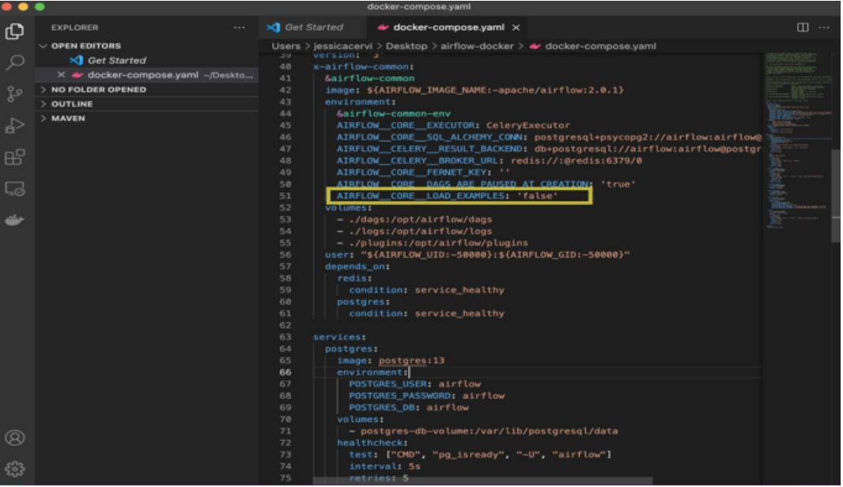

4. In a Terminal window, inside the airflow-docker folder, run the docker-compose up command to create and run the *containers*. Open Docker Desktop. You should see all of the *containers* up and running.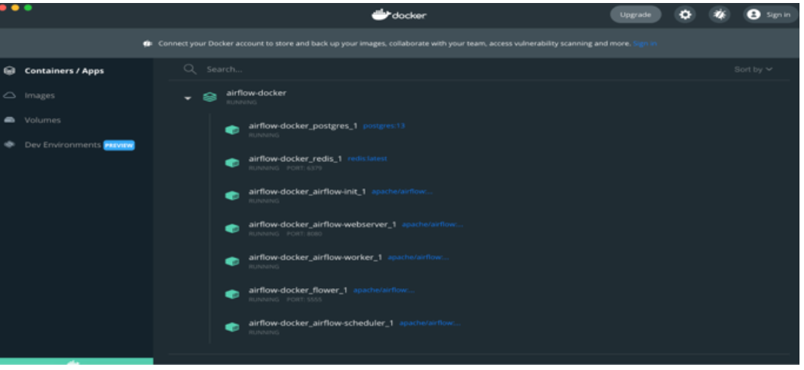

5. Open a new Terminal window and navigate to the airflow-docker folder. You should be able to see the dags, logs, and plugins folders that were automatically generated when you created the *containers*.6. Open a browser window and navigate to https://localhost:8080/. You should arrive at the Airflow login page and be prompted to provide your login credentials.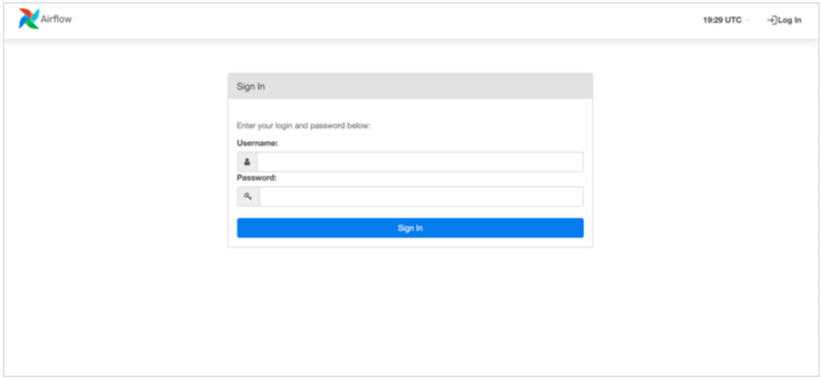

7. Access Airflow by entering “airflow” for both the username and password. Select “Sign In”. You should be redirected to the main page of the Airflow UI.

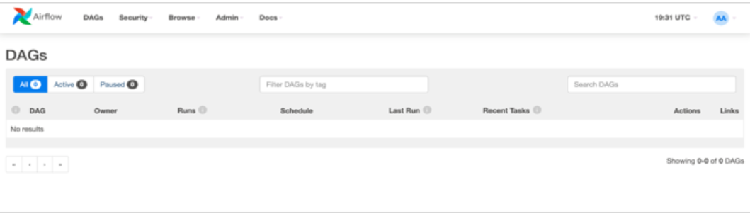Congratulations. You are now ready to start using Airflow.